
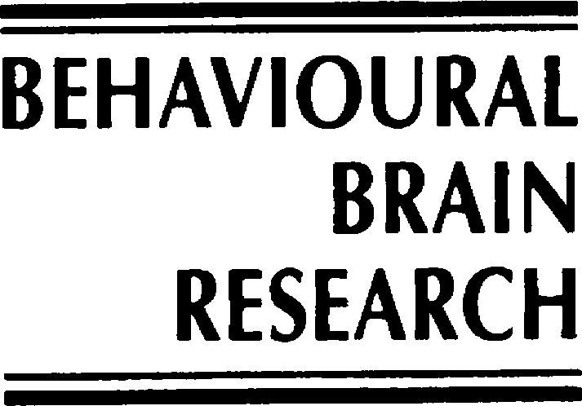
Behavioural Brain Research 101 (1999) 173 – 187

Research report

Is digital dexterity really related to corticospinal projections?: a re-analysis of the Heffner and Masterton data set using modern comparative statistics

Andrew N. Iwaniuk, Sergio M. Pellis, Ian Q. Whishaw *
Department of Psychology and Neuroscience, Uni6ersity of Lethbridge, Lethbridge, Alta. T1K-3M4, Canada

Received 26 June 1998; received in revised form 28 October 1998; accepted 28 October 1998

Abstract

Using a data set of 69 different mammalian species, Heffner and Masterton propose that the longer and deeper the ﬁbres of the corticospinal tract, the greater an animal’s digital dexterity. Because of the effects that phylogeny may have upon the extant phenotype of a given species, however, data from a wide range of species can rarely be considered to represent fully independent data points. Using modern comparative statistics, which incorporate phylogenetic information, we reanalysed their data set such that the assumption of independence was not violated. If Heffner and Masterton’s hypothesis is correct, then one would expect evidence of strong correlated evolution between corticospinal tract anatomy and digital dexterity once the effects of the phylogenetic relationships between the species in the data set have been removed. The results show that a distinct bias in the number of primate species sampled by Heffner and Masterton signiﬁcantly affected their ﬁndings. Furthermore, once phylogeny has been taken into account, only the length of the corticospinal tract ﬁbres showed a signiﬁcant relationship with two out of the four behaviours analysed, digital dexterity and hand– eye coordination. Based upon our results we recommend the use of modern comparative statistics for synthesising neural structure and behaviour, rather than examining structure– function relationships in an ahistorical context. It is also evident that there is a need for data on the length and depth of the corticospinal ﬁbres for a greater range of species so that the relationship between the corticospinal tract structure and motor behaviour for mammals as a whole can be more readily interpreted. © 1999 Elsevier Science B.V. All rights reserved.

Keywords: Corticospinal tract; Pyramidal tract; Dexterity; Hand– eye coordination; Diet; Locomotion; Independent contrasts; Autocorrelation

Introduction

In landmark papers, Heffner and Masterton [31,32] collated data on the structure of the corticospinal tract of 69 different mammalian species. Based upon the pattern of distribution of the anatomical features exam- ined (length, depth of penetration, density, size of ﬁbres, and area of tract) and the animals’ digital dexter-

* Corresponding author. Tel.: ˙1-403-329-2402; fax: ˙1-403-329- 2555.
E-mail address: whishaw@hg.uleth.ca (I.Q. Whishaw)
ity, derived from Napier’s model [47], they concluded that the longer (further along the spinal cord they travel) and deeper (depth of penetration within the spinal cord) the ﬁbres of the corticospinal tract, the greater the dexterity of a given species. They further suggested that the evolution of longer and deeper ﬁbres occurred early within the primate lineage and that it has culminated in the long, deep tracts observed in modern humans [32]. Their theory of the evolution of the corticospinal tract has since been cited as evidence for the importance of long and deep corticospinal ﬁbres in the execution of complex digit movements, e.g. [4,41].

0166-4328:99:$ - see front matter © 1999 Elsevier Science B.V. All rights reserved. PII: S0166-4328(98)00151-X

It has become increasingly accepted in recent years that due to a shared ancestry, species cannot be used as fully independent data points, a central assumption to conventional parametric and non-parametric statistics. The concept of lack of independence of species as data points has recently become pervasive throughout the ﬁeld of comparative biology and has resulted in the development of a number of new statistical methods which incorporate phylogenetic information and thus remove the effects of non-independence [20,23,30]. De- spite the extensive use of these new methods in the analysis of ecology, evolution and comparative physiol- ogy, e.g. [1,15,19,22], they have yet to be used exten- sively in the examination of structure– function relationships in comparative neuroscience (for an ex- ception see [12]). Heffner and Masterton [32] did at- tempt to address this issue and incorporate some phylogenetic information into their analyses, but they did so by analysing their anatomical traits at ‘phyletic levels’. The use of ‘phyletic levels’, as performed by Heffner and Masterton [32], does not accurately reﬂect phylogenetic distance, but is rather an attempt to demonstrate how the corticospinal tract has evolved from so-called ‘basal’ taxa, such as marsupials, through to ‘higher level’ taxa (e.g. hominids). Even if these levels are taken as a progression index, there is little evidence to support the choice of levels as representative of ‘stages’ in human evolution (particularly the use of New World or platyrrhine primates as an intermediate between prosimians and Old World or catarrhine pri- mates). In addition, the phyletic levels used by Heffner and Masterton vary widely. That is, it begins with the sub-class level, then through two orders, a suborder, and three successive families to terminate in a single species, humans. Thus, even if this progression index is an accurate representation of phenotypes ancestral to the human lineage, the analysis of traits at such widely varying phylogenetic distances is not likely to produce correct results because it is not linear. Finally, by not incorporating relatedness between the species, indepen- dence of the data points is compromised, casting doubt upon conclusions regarding the relationship between the neural structure and behaviour. This is speciﬁcally important for the Heffner and Masterton data set because it contains species which are differentially re- lated to one another (i.e. a wide variance in the degree of relatedness between individual species) which makes the data set as a whole particularly prone to the con- founding effects of phylogeny.
A second problem with the data set, is that some groups are over-represented and others under-repre- sented in the sample. Thus, some of the relationships between the structures and digital dexterity may result from the polarisation of the relationship at either end of a spectrum without suitable representatives in be- tween. If we take the species from Heffner and Master-
ton’s data set for which data on the depth and length of the corticospinal tract is known (Table 1) and plot it against digital dexterity (Fig. 1), it is clear that the primates are all found in a common area, distinct from the remaining 13 species (Table 1). Thus, without ac- counting for the effects of phylogeny and over sampling of primates as a whole, the relationship between the anatomy of the tract and digital dexterity is suspect. To resolve the relationships between the anatomy of the corticospinal tract and digital dexterity, we chose to reexamine the Heffner and Masterton data set [31,32] using modern comparative methods that incorporate phylogenetic information. We tested for the strength of the evolutionary relationship between the length and depth of the corticospinal tract and digital dexterity, as well as the possible effects of over-sampling of pri- mates. Also, to further examine the relationship be- tween the corticospinal tract and digital dexterity, we have incorporated data on other motor behaviours that
require ﬁne control of the forelimb.
Grillner [27] proposed that skilled limb movements, and thus digital dexterity, are derived from limb posi- tioning and grasping during arboreal locomotion. To test this theory regarding the evolution of reaching and grasping movements we examined the relationship be- tween corticospinal tract anatomy and arboreality.
In a study of the amount of cortex devoted to the corticospinal tract in various mammals, Nudo and Masterton [49] related the relative amount of cortex to dexterity, hand– eye coordination, food preference, trophic level and foraging and nesting locations. This implies that these behaviours may also be related to the anatomy of the corticospinal tract itself. Based upon Nudo and Masterton’s [49] ecological variables, we also examined the relationship between the length and depth of the corticospinal tract, feeding behaviour (i.e. preda- tion) and hand– eye coordination.
If digital dexterity, arboreality, predation and hand– eye coordination, are related to corticospinal tract de- velopment, then we would expect to ﬁnd evidence of strong correlated evolution between corticospinal tract length and depth and different motor behaviours once the data are made independent (i.e. the effects of phy- logeny are removed). Furthermore, if over sampling has not seriously affected the results by polarising the data, then accounting for phylogeny should have little effect upon the relationships between the anatomical and behavioural data.

Materials and methods

  - Data

Data on the length and depth of the corticospinal tracts and dexterity of 25 species were taken from

reports cited in Heffner and Masterton [31,32] (Table 1). Only 25 out of the original 69 species were exam- ined because these were the only species in their data set for which both the length (furthest distance down the spinal cord) and the depth (deepest area of termi- nation of the ﬁbres within the spinal cord) of the corticospinal ﬁbres are known. Most of the other spe- cies which Heffner and Masterton examine have only partial information or other anatomical variables which were not of present interest (e.g. area of tract, ﬁbre size, number of ﬁbres, etc.).
Previous studies which have attempted to correlate so-called ‘ecological variables’ with descending path- ways treated the variables categorically [49,50]. We found it more meaningful to examine such variables as continuous as their distribution among species is more likely to be arranged along a continuum rather than step-wise through a series of hierarchical categories. Therefore, data on the degree of arboreality and per- centage of animal matter in the diet were arranged such that a continuum of values existed for the species being examined. These values ranged from never climb
(0) to always in the trees (4) and no animal matter

Table 1
The anatomical and behavioural traits used the comparative analysisª
eaten (0) to 100% animal matter eaten (4). No attempt was made to differentiate between insectivorous and carnivorous (vertebrate eating) species as it was as- sumed that both feeding types would require some degree of ﬁne motor control if they are to catch prey [14].
The data on hand– eye coordination was based upon the scale used by Nudo [50] in an analysis of the tectospinal tract in mammals. Essentially, this scale is a rating of whether the animal uses visually guided forelimb movements or not.

  - Comparati6e methods

Two different comparative methods were used in the reanalysis of Heffner and Masterton’s data set. As branch lengths are uncertain between such a diverse array of species, taxonomic ranks were used and this has been found to yield different results in simulation tests [45,57]. Thus, it is necessary to use two methods in order to give greater conﬁdence to the results. Fur- thermore, the two methods examine slightly different aspects of phylogenetic ‘effect’ (discussed below).

Species |  | Depth | Length | Dexterity | Arboreality | Diet | Hand–eye
Spider monkey | Ateles ater | 5 [51] | 8 [53] | 4 | 4 | 0 | 2
Dog | Canis familiaris | 3 [6] | 6 [6] | 2 | 0 | 2 | 1
Goat | Capra hircus | 1 [28] | 1 [28] | 1 | 0 | 0 | 0
Capuchin monkey | Cebus apella | 5 [52] | 8 [53] | 5 | 3 | 2 | 2
Vervet | Cercopithecus pygerythrus | 5 [52] | 8 [53] | 6 | 3 | 1 | 2
Nine-banded armadillo | Dasypus no6emcinctus | 3 [18] | 2 [18] | 1 | 0 | 3 | 1
Virginia opossum | Didelphis 6irginiana | 3 [2] | 2 [42] | 3 | 2 | 2 | 0
Cat | Felis domesticus | 3 [51] | 7 [51] | 2 | 1 | 4 | 2
Greater bushbaby | Galago crassicaudatus | 4 [17] | 7 [17] | 5 | 4 | 2 | 1
Human | Homo sapiens | 5 [39] | 8 [39] | 7 | 1 | 2 | 2
Gibbon | Hylobates lar | 5 [52] | 7 [53] | 6 | 4 | 0 | 2
Woolly monkey | Lagothrix lagotricha | 5 [53] | 8 [53] | 5 | 4 | 1 | 2
Rhesus macaque | Macaca mulatta | 5 [52] | 8 [53] | 6 | 3 | 2 | 2
Coypu | Myocastor coypus | 1 [25] | 7 [25] | 3 | 0 | 0 | 1
Slow loris | Nycticebus coucang | 5 [8] | 7 [7] | 5 | 4 | 3 | 2
Chimpanzee | Pan troglodytes | 5 [53] | 8 [53] | 6 | 2 | 2 | 2
Potoroo | Potorous tridactylus | 2 [43] | 4 [43] | 2 | 0 | 0 | 1
Kinkajou | Potos ﬂa6us | 5 [29] | 6 [29] | 3 | 3 | 1 | 2
Raccoon | Procyon lotor | 5 [54] | 7 [62] | 3 | 2 | 2 | 2
Norway rat | Rattus nor6egicus | 3 [26] | 7 [26] | 3 | 1 | 1 | 1
Cotton-top marmoset | Saguinus oedipus | 1 [60] | 7 [60] | 4 | 4 | 2 | 2
Squirrel monkey | Saimiri sciureus | 4 [29] | 7 [64] | 5 | 4 | 1 | 2
Quokka | Setonix brachyurus | 1 [65] | 3 [65] | 3 | 0 | 0 | 1
Brush-tailed possum | Trichosurus 6ulpecula | 3 [44] | 4 [44] | 3 | 2 | 1 | 1
Tree shrew | Tupaia glis | 1 [37] | 4 [61] | 3 | 2 | 3 | 1
ª The length and depth columns refer to: the depth of penetration of the corticospinal tract ﬁbres into the spinal cord with: 1, lamina VI; 2, lamina VII; 3, lamina VIII; 4, lamina IX; and 5, lamina X; and length of the ﬁbres down the spinal cord with: 1, cervical; 2, upper thoracic; 3, mid-thoracic; 4, lower thoracic; 5, upper lumbar; 6, lower lumbar; 7, sacral; and 8, coccygeal. The dexterity index, a measurement of the digit dexterity of a species, was taken from Heffner and Masterton [31,32]. The arboreality column refers to the relative amount of time each species spends in the trees. The diet category was based upon the relative amount of animal matter (i.e. measurement of predatory behaviour) present in the diet of each of the 25 species. The ‘hand–eye’ column refers to the hand–eye coordination index given in Nudo and Masterton [49]. References for the anatomical data are indicated by the numbers associated with each anatomical character.

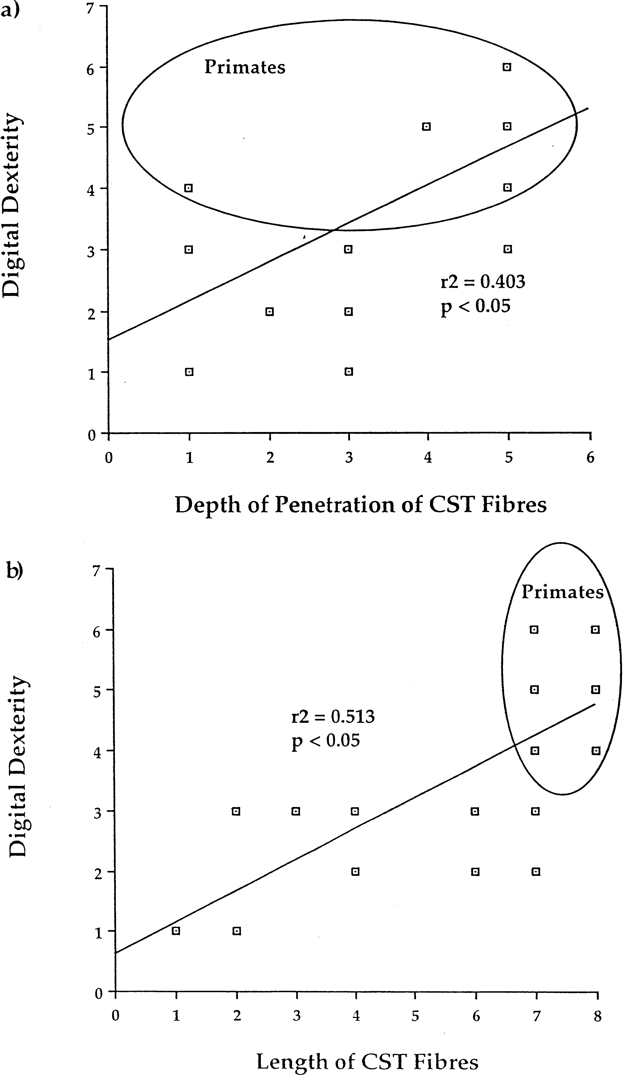
Fig. 1. These two scatterplots are based upon data obtained from Heffner and Masterton [31,32] on the depth of penetration of the corticospinal tract ﬁbres (a) and length of the corticospinal tract (b) and digital dexterity. Note that in both cases primates form a distinct group from all the other data points. It should also be noted that although only ﬁve and six data points are visible for the primates, they actually represent 10 different species (see Table 1).
    - Autocorrelation correlation of the anatomy of the corticospinal tract To ﬁrst determine whether the over sampling of and the behavioural indices was assessed using a certain taxa and non-independence of data have af- Moran’s I-test. A Moran’s I-test reveals the pattern of fected previous results, the amount of phylogenetic variation in a trait relative to phylogenetic distance or

taxonomic position by examining the amount of co- variance of a trait across taxa divided by a measure of variance [23]. The I statistics are calculated for each level and then plotted on a graph in order to determine where autocorrelation varies the most with taxon level or phylogenetic distance. The rank at which the Moran value is highest is taken as the point at which the greatest amount of phylogenetic correlation occurs [40]. A nested ANOVA or AN- COVA can be used instead of the Moran’s test, but the Moran’s test was chosen in this instance because it incorporates more phylogenetic information than an ANOVA:ANCOVA and thus is less prone to any po- tential source of error derived from non-independence [23].
Once the appropriate level has been determined, us- ing spatial autoregression techniques, the variation in the trait of interest can be divided into two compo- nents: a phylogenetic and an environmental compo- nent [10,23,30]. This is calculated through the use of a weighted matrix which encodes the phylogenetic re- latedness of the species being examined. Using this matrix, predicted values of the trait can be calculated and correlated with the observed values to yield the phylogenetic component of the variation. Thus, if the actual values of the trait are largely predicted by the matrix, then the amount of variation attributable to phylogeny is high.
To perform both of these analyses, the phylogenetic autocorrelation (PA) program was used [40]. As branch lengths between such diverse taxa are uncer- tain (also see above) and estimating such relationships is fraught with its own set of complications, taxo- nomic ranks were used to calculate the degree of re- latedness of the species being examined.

    - Independent contrasts
To examine the correlation between the anatomical and behavioural traits, we used Felsenstein’s [16] in- dependent contrasts approach to correct for the ef- fects of phylogeny. The method of independent contrasts compares pair-wise trait values at each node of the phylogeny, with each comparison (or contrast) scaled by an expected S.D. [21,23,30]. These devia- tions are derived from information on the branch lengths of the phylogeny and a model of evolutionary change. Once more, as branch lengths are unknown and the phylogeny of all of the species is incomplete (i.e. not every species was examined within every taxon or clade), a speciational model of evolutionary change was used [1,15,21]. That is, evolutionary change only occurs at speciation events and thus, each branch length was standardised to a value of 1. The phylogeny of the species was taken from a number of sources (Fig. 2) [48,56,63], but it should be noted that the relationships between the taxa are rea-
sonably well established. The phylogeny was loaded into the comparative analysis of independent con- trasts (CAIC) program [58], as well as the data set, and the contrasts calculated. All of the traits were considered to be continuous, so the ‘crunch’ option was used as recommended by the authors [58]. This option in the program calculates positive contrasts as those dependent variables which vary in the same di- rection as the independent variable. Conversely, nega- tive contrasts are those dependent variables which vary in the opposite direction to the independent variable.
In accordance with previous comparative studies on the corticospinal tract, the depth and length of corti- cospinal ﬁbres were considered to be both dependent and independent variables, depending on the compari- son being made. As the progressive evolution towards a more arboreal and predatory lifestyle is thought to affect the corticospinal tract anatomy [49], length and depth were dependent variables in these instances. Dexterity and hand– eye coordination were, however, examined as independent variables. This is due to the theory that long and deep ﬁbres are required in order for these behaviours to occur [4,31,32,49], as opposed to the occupation of a different ecological niche caus- ing the development of longer and deeper ﬁbres.
The output was then regressed through the origin [21], and an F-test for signiﬁcance was performed on each resulting regression line.

Results

  - Autocorrelation

As there were no congeneric species in this com- parison, the shortest phylogenetic distance which could be examined was that of family, which ade- quately described each species as each one was a rep- resentative of a distinct sub-family or family. The depth of penetration of corticospinal ﬁbres did not, however, exhibit an autocorrelation pattern (i.e. high at low distances and progressively decreasing as phy- logenetic distance increases) which suggests that it has little phylogenetic afﬁnity (Fig. 3a). The length of the corticospinal tract itself (Fig. 3b), as well as all four of the behavioural measures (Fig. 4), showed the highest amount of phylogenetic correlation at the or- der level. Subsequent analysis using autoregression to determine the amount of variation which can be at- tributed to phylogeny was performed on the length of the corticospinal tract and the behavioural measures (Table 2). Most of the r ² values were substantial (i.e. greater than 40%), although the amount of phyloge- netic variation in the diet measurement was only 1.5%.

  - Independent contrasts

All four variables, with the effects of phylogeny removed, were compared against both the length and depth of the corticospinal tract ﬁbres (Figs. 5 – 7). Only two regression lines were statistically signiﬁcant, that of dexterity and hand– eye coordination with the length of the corticospinal tract (Fig. 5b and Fig. 6c). Conversely, no signiﬁcant relationship was observed between the depth of penetration of corticospinal tract ﬁbres for any of the four variables (Fig. 5aFig. 7), nor was any relationship observed between diet and arboreality and length of the corticospinal tract (Fig. 6a and b). Note that the relationships between depth and length of the corticospinal tract and dex- terity are quite different from that of the raw data (Fig. 1), once the effects of phylogeny are removed (Fig. 5).

Discussion

  - Usefulness of comparati6e methods in neuroethology

This study demonstrates that once phylogeny is ac- counted for, the synthesis of neuroanatomy and be- haviour can change signiﬁcantly, especially when data from some groups are over-represented in the sample. The push to use comparative techniques which incorpo- rate phylogeny has been overwhelming and some meth- ods require improvement (e.g. using speciﬁc sets of F-ratios calculated from simulations of data to yield more accurate degrees of freedom and p-values [20] before they can yield more accurate results; see also Refs. [3,59]).
Concern has also been raised in the literature regard- ing the use of different branch lengths [13,20,21]. Al-

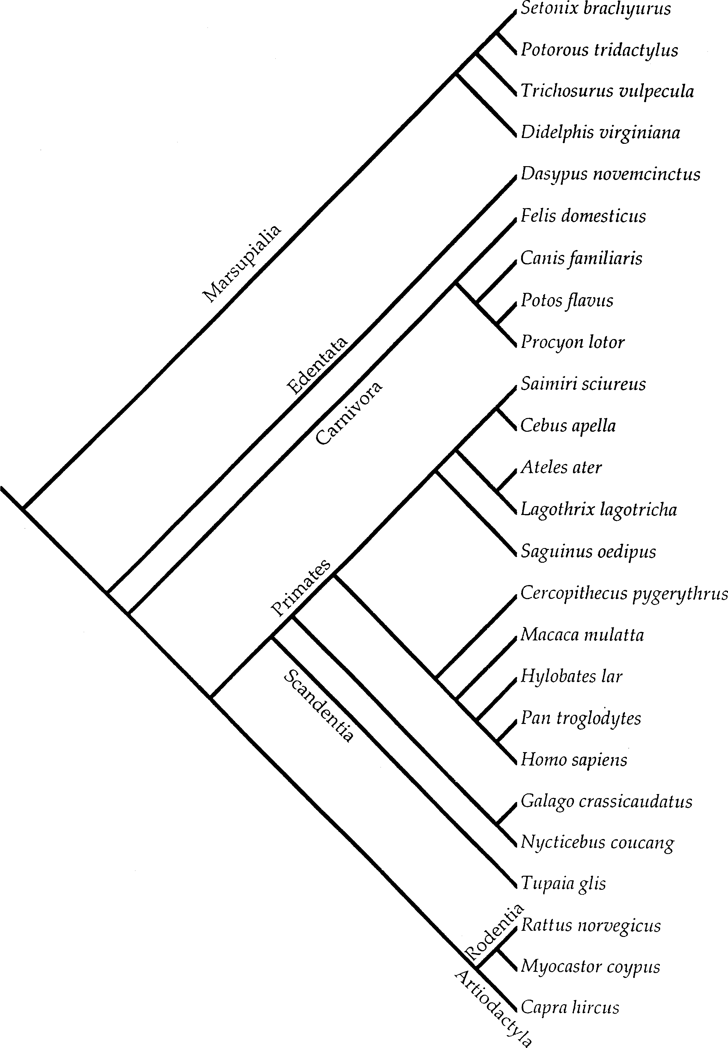

Fig. 2. This is the theorised phylogeny of the 25 species examined. Branching points for higher level taxa were largely taken from Novacek [47]. The branching of the marsupials is based on that of Springer and Kirsch [62] and of primates from Purvis [55].

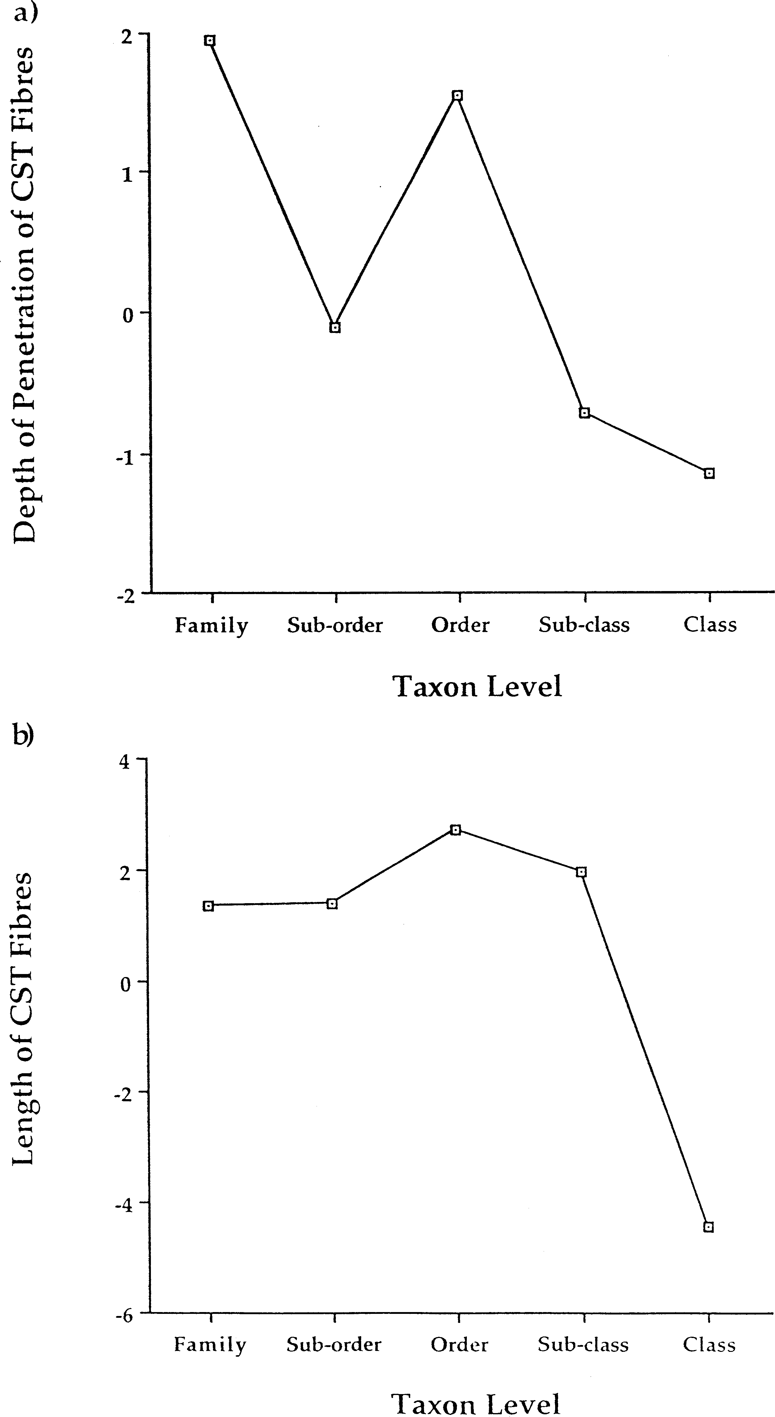
Fig. 3. The results of Moran’s I-test for phylogenetic correlation for (a) the depth of penetration of the corticospinal tract and (b) length of the corticospinal tract. The y-axis represents the z-scores calculated from the Moran portion of the PA program and the x-axis, the taxonomic levels at which the values were calculated. Note that there is no genus level as there were no congeneric species in this study.

though the use of equal branch lengths has been sug- ised following the procedures outlined in Garland et al. gested to be the more reliable and conservative ap- [21]. The regressions of the absolute values of the proach [15,45], we did test the independent contrasts to independent contrasts against the square-roots of the determine whether they had been adequately standard- branch lengths indicates that all of the contrasts, except

for hand– eye coordination, were adequately standard- ised (Table 3). Thus, the results obtained above have been effectual in incorporating phylogenetic informa- tion without introducing any additional biases. The lack of proper standardisation of the hand– eye coordi- nation index is problematic, but likely results from the inadequacy of the index itself (see below), rather than any inherent problems in the statistical methods employed.
Regardless of the statistical concerns with regard to these comparative methods, we feel that the incorpora- tion of phylogenetic information at any level outweighs any potential costs of increased type II error rate
[13,19,20,30]. Therefore, based upon our own results using Heffner and Masterton’s data set, we highly recommend the use of comparative methods in deter- mining the relationship between structure and function in an interspeciﬁc fashion.

  - Phylogenetic correlation of the data

The high amount of phylogenetic correlation with order level taxa supports one of our original hypotheses that there may be a polarising effect in the analysis of the descending pathways of the spinal cord. This is best shown by the partitioning of the variance in the length

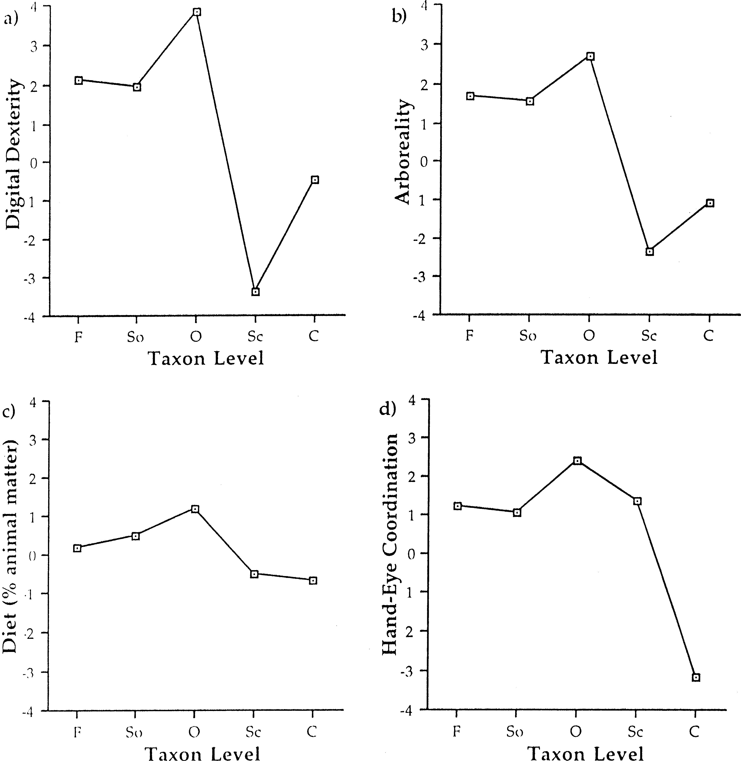

Fig. 4. The results of Moran’s I-test for phylogenetic correlation for the four behavioural measures: (a) dexterity, (b) arboreality, (c) diet and (d) hand– eye coordination. As with Fig. 3,the y-axis represents the z-scores calculated by the PA program for each taxonomic level (x-axis). The taxon levels are as follows: ‘F’, family; ‘So’, sub-order; ‘O’, order; ‘Sc’, sub-class; and ‘C’, class. All four of the measures showed the highest amount of correlation with phylogeny at the order level.

Table 2
Results from the autocorrelation analysisª

Trait | a | r | True r ²
Depth | – | – | –
Length | 4.6 | 0.50 | 0.361
Digital dexterity | 3.0 | 0.69 | 0.676
Arboreality | 2.5 | 0.54 | 0.447
Diet | 5.4 | 0.09 | 0.015
Hand–eye coordination | 1.2 | 0.66 | 0.627
ª a Refers to the power of the weighting matrix; r refers to the autocorrelation coefﬁcient and the true r ² is the proportion of the variance which can be attributed to phylogenetic relatedness. Note that there are no values for ‘depth’ as the variation in depth of penetration of the corticospinal tract ﬁbres did not exhibit an auto- correlation pattern (see Section 3).

of the corticospinal tract and behavioural traits into phylogenetic and environmental components. The large values for the phylogenetic components (with the notable exception of diet) suggest that the length of the tract and three of the motor behaviours are highly conserved phylogenetically.
With respect to the length of the tract, this suggests that the length of the corticospinal tract of a species’ ancestors has a large inﬂuence upon the length of the corticospinal tract of the descendant species. For ex- ample, primates have long corticospinal tracts princi- pally because members of the ancestral lineage did. The length of the tract may, however, still be related to the development or performance of particular be- haviours (see below), but in order to assess the struc- ture– function relationship, information on the relatedness between species is necessary because of the signiﬁcant effects of phylogeny on the length of the tract.
The same cannot be said, however, for the depth of penetration of the corticospinal tract and diet which both vary greatly from group to group. Therefore, the analysis of the depth of the ﬁbres could be con- ducted without taking phylogenetic relationships into account. If, however, one attempts to correlate ﬁbre depth with some other factor which shows some phy- logenetic correlation, comparative methods must be used (see below).
Three of the four motor behaviours, digital dexter- ity, arboreality and hand– eye coordination, showed strong associations with phylogeny. The principal rea- son for this appears to be the gross over-representa- tion of primates (12 out of the 25 species examined; 13 out of the 25 species if Scandentia is considered to be closely related to the Primate order). Most pri- mates are highly arboreal, particularly those within this data set, as well as being quite dextrous and possessing visually guided forelimb movements (for a review see Ref. [38]).
The possible skew in terms of the diversity of loco- motory types and degrees of hand– eye coordination represented can only be overcome by an increase in the amount of data for species which possess no ar- boreal abilities whatsoever and who are considered to have a limited ability to visually guide forelimb move- ments (e.g. Cetaceans, Pinnipeds, Artiodactyls).
Finally, the diet measure may also share some of the same problems of over-representation. Out of the 23 species, only four species showed moderate to high levels of predation. In order to obtain a more com- plete picture of the diversity of the anatomical and behavioural measures used within this study, it would be necessary to include a great many more species, particularly those orders which have been omitted completely (e.g. Perissodactyla, Chiroptera, Insec- tivora, Cetacea and Monotremata). There is some scanty information for members of these groups with respect to the corticospinal tract anatomy [5,24,64], but in choosing the species from Heffner and Master- ton’s data set, we selected only those species for which both the length and depth of the ﬁbres were well established.

  - Digital dexterity

Based upon the superﬁcial pattern of distribution of the length and depth of the tract and the degree of dexterity, Heffner and Masterton [31,32] proposed that the longer and deeper the ﬁbres of the corti- cospinal tract, the ﬁner the control of the digits and the greater the dexterity. Despite the signiﬁcant rela- tionship between the length, and not the depth, of the tract and dexterity, it is important to acknowledge that the presently used dexterity index (based upon Napier [47]) has some serious ﬂaws in accurately en- coding a species’ actual dexterity [33,35,36]. One ex- ample of this is the rat which Heffner and Masterton [31,32] gave a dexterity value of 3. It is clear from the work of Whishaw and colleagues, who have demonstrated that the rat is not only capable of sin- gle paw grasps with different paw postures [66], but also independent digit movement [67], that the rat should receive a ranking of 5 or 6. The same can be said of the chimpanzee which is clearly capable of a ﬁnely tuned precision grasp [11,46] and should there- fore receive a rank of 7 and not 6. The raccoon, however, which Heffner and Masterton tentatively gave a 3, was appropriately ranked, contrary to the common misconception that racoons possess a ‘pri- mate-like’ ability to handle objects [36]. The extent to which this index is incorrect for other species is not clear, but as more data are amassed on the ‘true’ dexterity of different species [33 – 36,69], it has become evident that a new index is required. A preliminary index based upon a multi-trait character matrix has

been used in the examination of marsupial dexterity [34], but the extent to which this new index can be readily applied to other species has yet to be fully evaluated.
The functional signiﬁcance of the length of the corti- cospinal tract has yet to be fully explored. It is interest- ing, however, that even without the large amount of phylogenetic correlation for both dexterity and length of ﬁbres, there is still a signiﬁcant relationship. Clearly,
this is an area for further research with respect to how the length of the corticospinal tract results in a greater amount of dexterity and has interesting repercussions when considering the correlated evolution of the tract and digital dexterity (see below).
Most of the research into digital dexterity has been primarily concerned with the depth of penetration of corticospinal ﬁbres. It has been stated repeatedly throughout the literature that the primary factor medi-

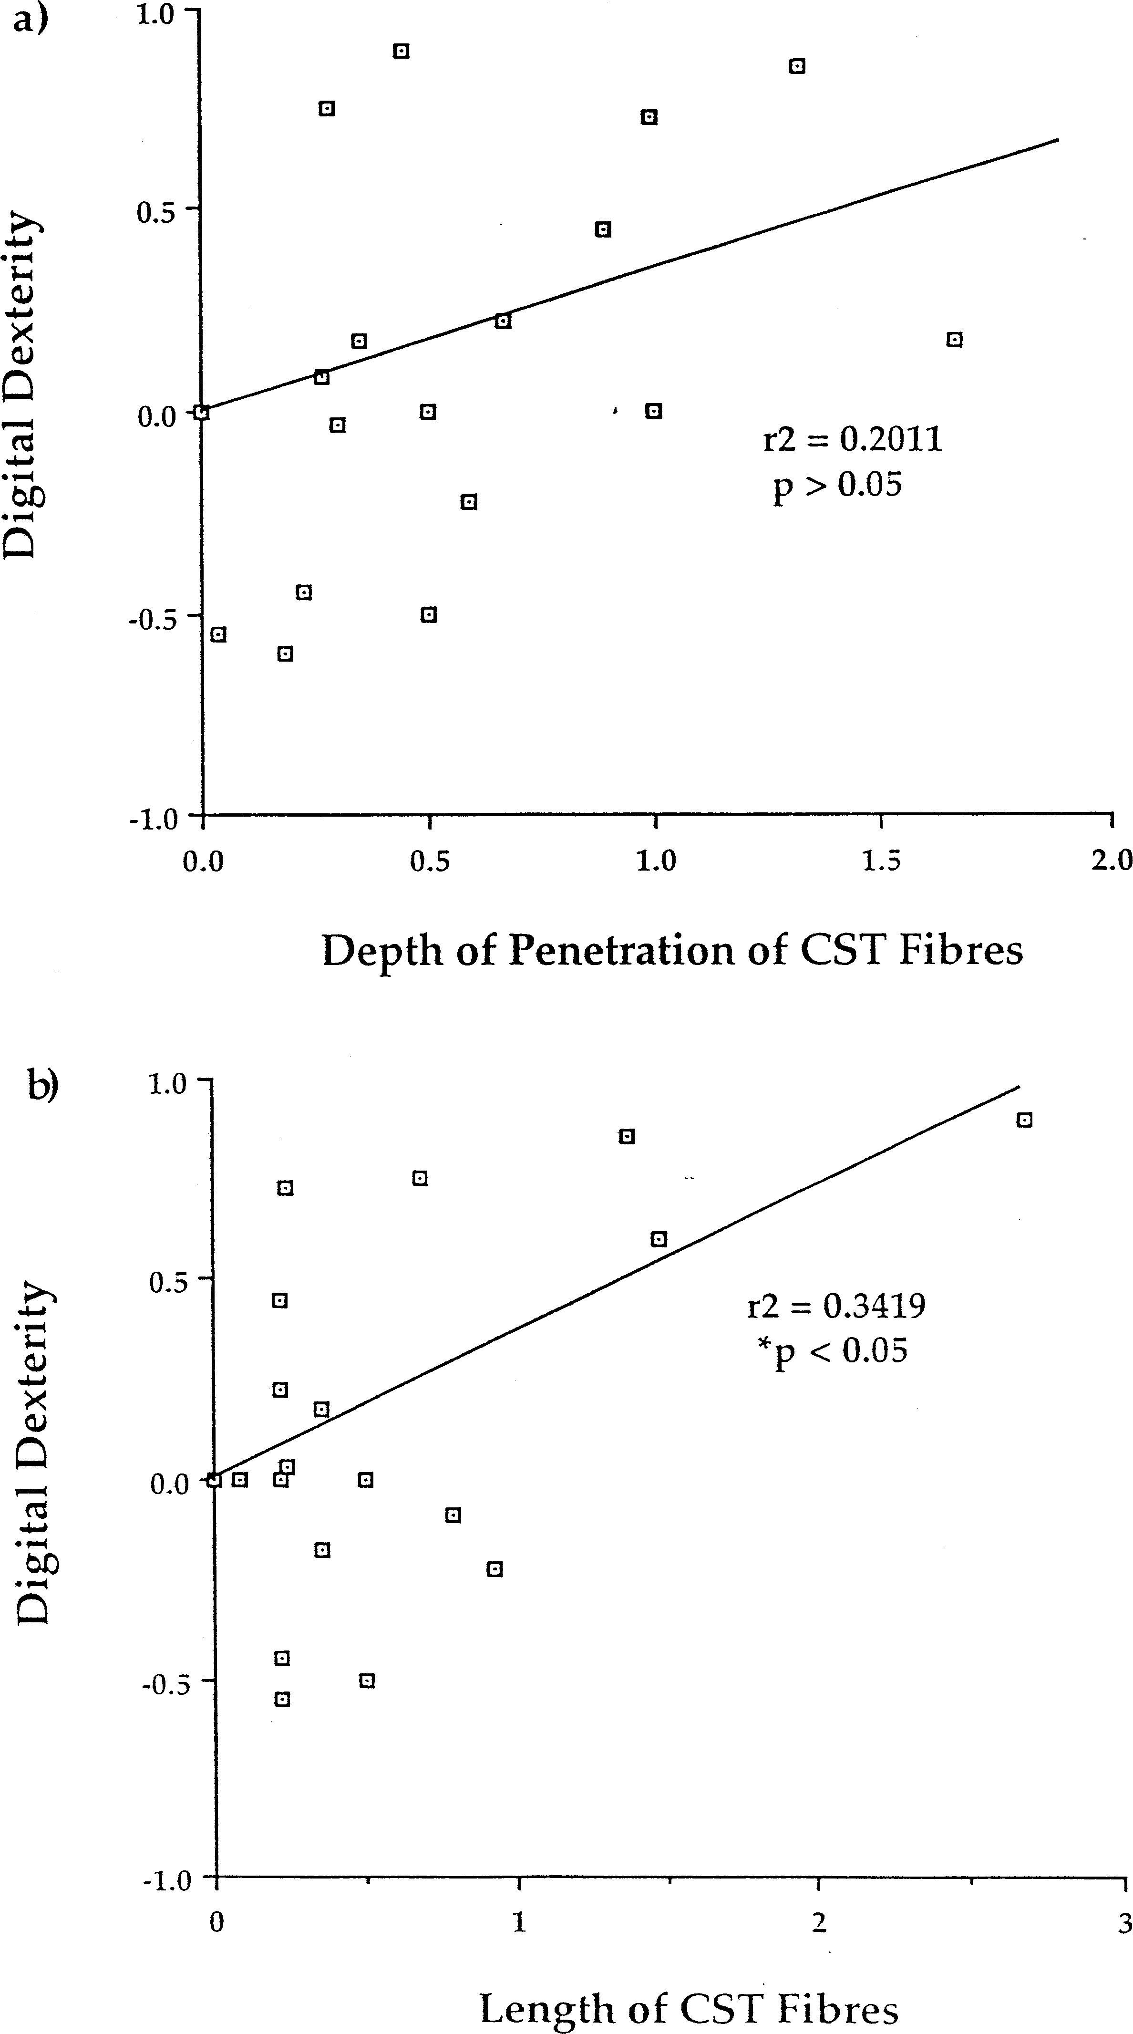
Fig. 5. These graphs represent the regression lines through the origin and plots of the independent contrasts calculated by CAIC for both the length (a) and depth of penetration (b) of the corticospinal ﬁbres and digital dexterity. The only signiﬁcant regression line is that of the length of corticospinal ﬁbres and digital dexterity.

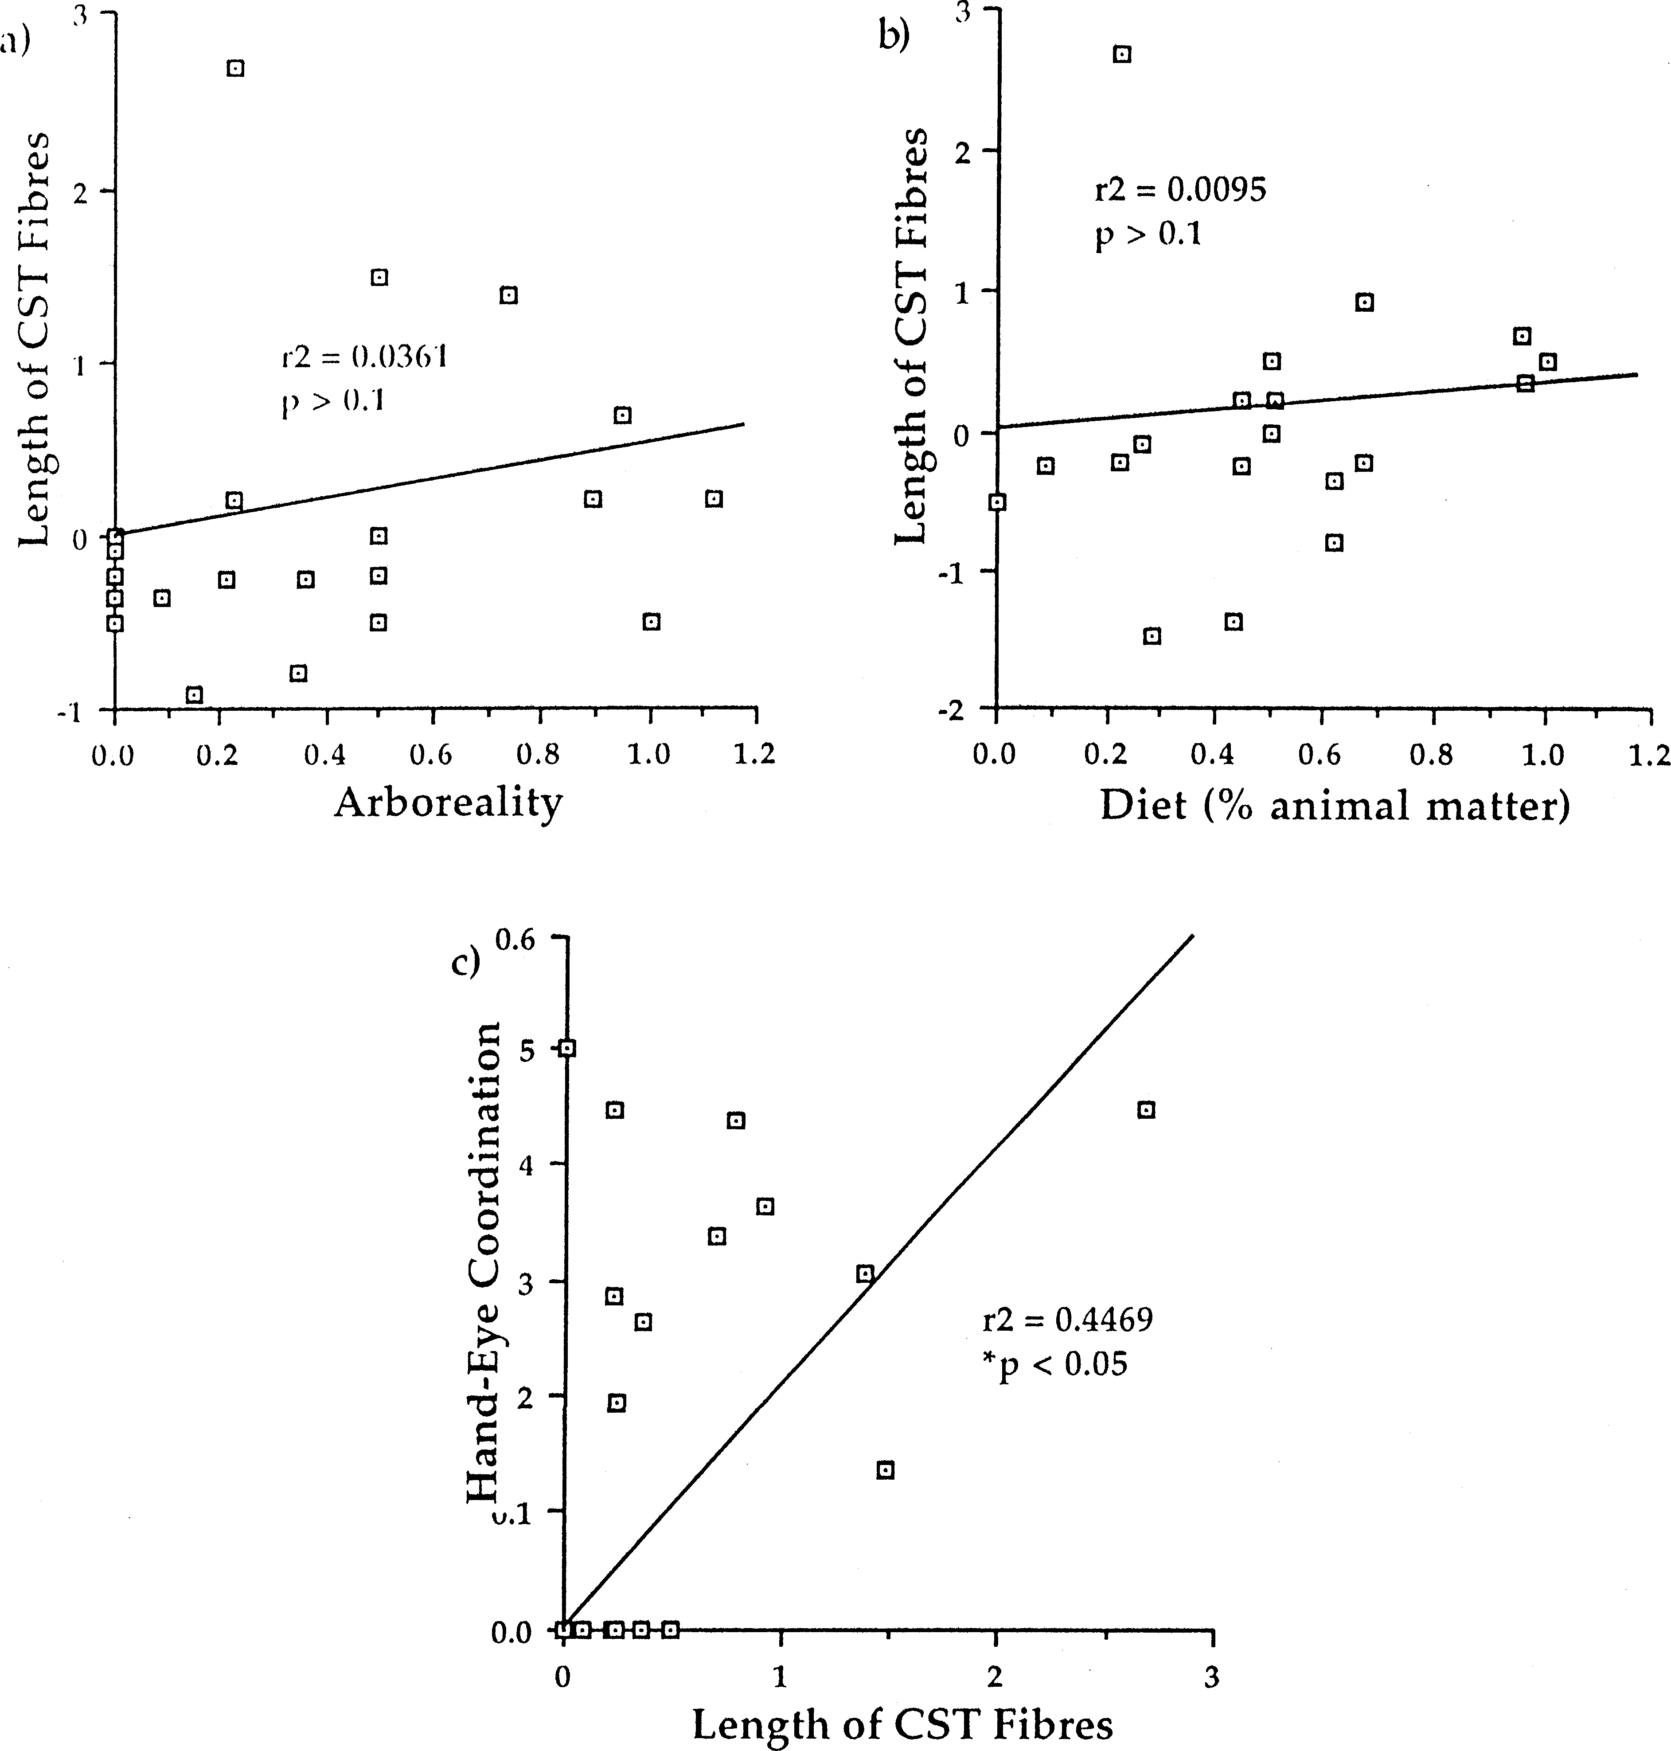
Fig. 6. These graphs represent the independent contrasts calculated for the length of the corticospinal ﬁbres and the following behavioural variables: (a) arboreality, (b) diet and (c) hand– eye coordination. Only the relationship between the ﬁbre length and hand– eye coordination was signiﬁcant.

ating the degree of dexterity exhibited by a species is the depth to which the corticospinal tract penetrates [4,31,32,55]. The most often cited reason for such a relationship is that the deeper the ﬁbres penetrate, the greater the amount of direct corticomotoneuronal con- nections. Recent evidence has suggested, however, that penetration to lamina IX may not be essential for direct connections to occur [41]. In fact, connections to lami- nae VII and VIII may be sufﬁcient, which may explain the lack of relationship found between ﬁbre depth and dexterity observed in this study.
  - Arboreality

The lack of a signiﬁcant relationship between the corticospinal tract anatomy and degree of arboreality casts some doubt upon the hypothesis that a long and deep corticospinal tract is required for ﬁne control of the hand. Most arboreal mammals, and particularly those examined in this study, use their hands exten- sively in arboreal locomotion [9]. In fact, in some species, such as those moving around in the ﬁne branch domain (e.g. slow loris), one could make the claim that

ﬁne motor control is required for effective arboreal locomotion. Thus, a lack of a signiﬁcant relationship between arboreality and the corticospinal tract may suggest that the corticospinal tract is not essential for grasping per se, but for some other factor which is related to hand-use. Furthermore, Grillner’s theory [27] that skilled limb use is derived from arboreal locomo- tion does not appear to hold with respect to the anatomy of the corticospinal tract.
  - Diet

It has been previously suggested that dexterity is related, to some extent, to the degree of carnivory [22] and earlier comparative analyses of neuroanatomical data frequently incorporate diet at some level, e.g. [49,50]. We found no evidence, however, of a signiﬁcant relationship between our diet measure and corticospinal tract anatomy. This may also be an artifact of the

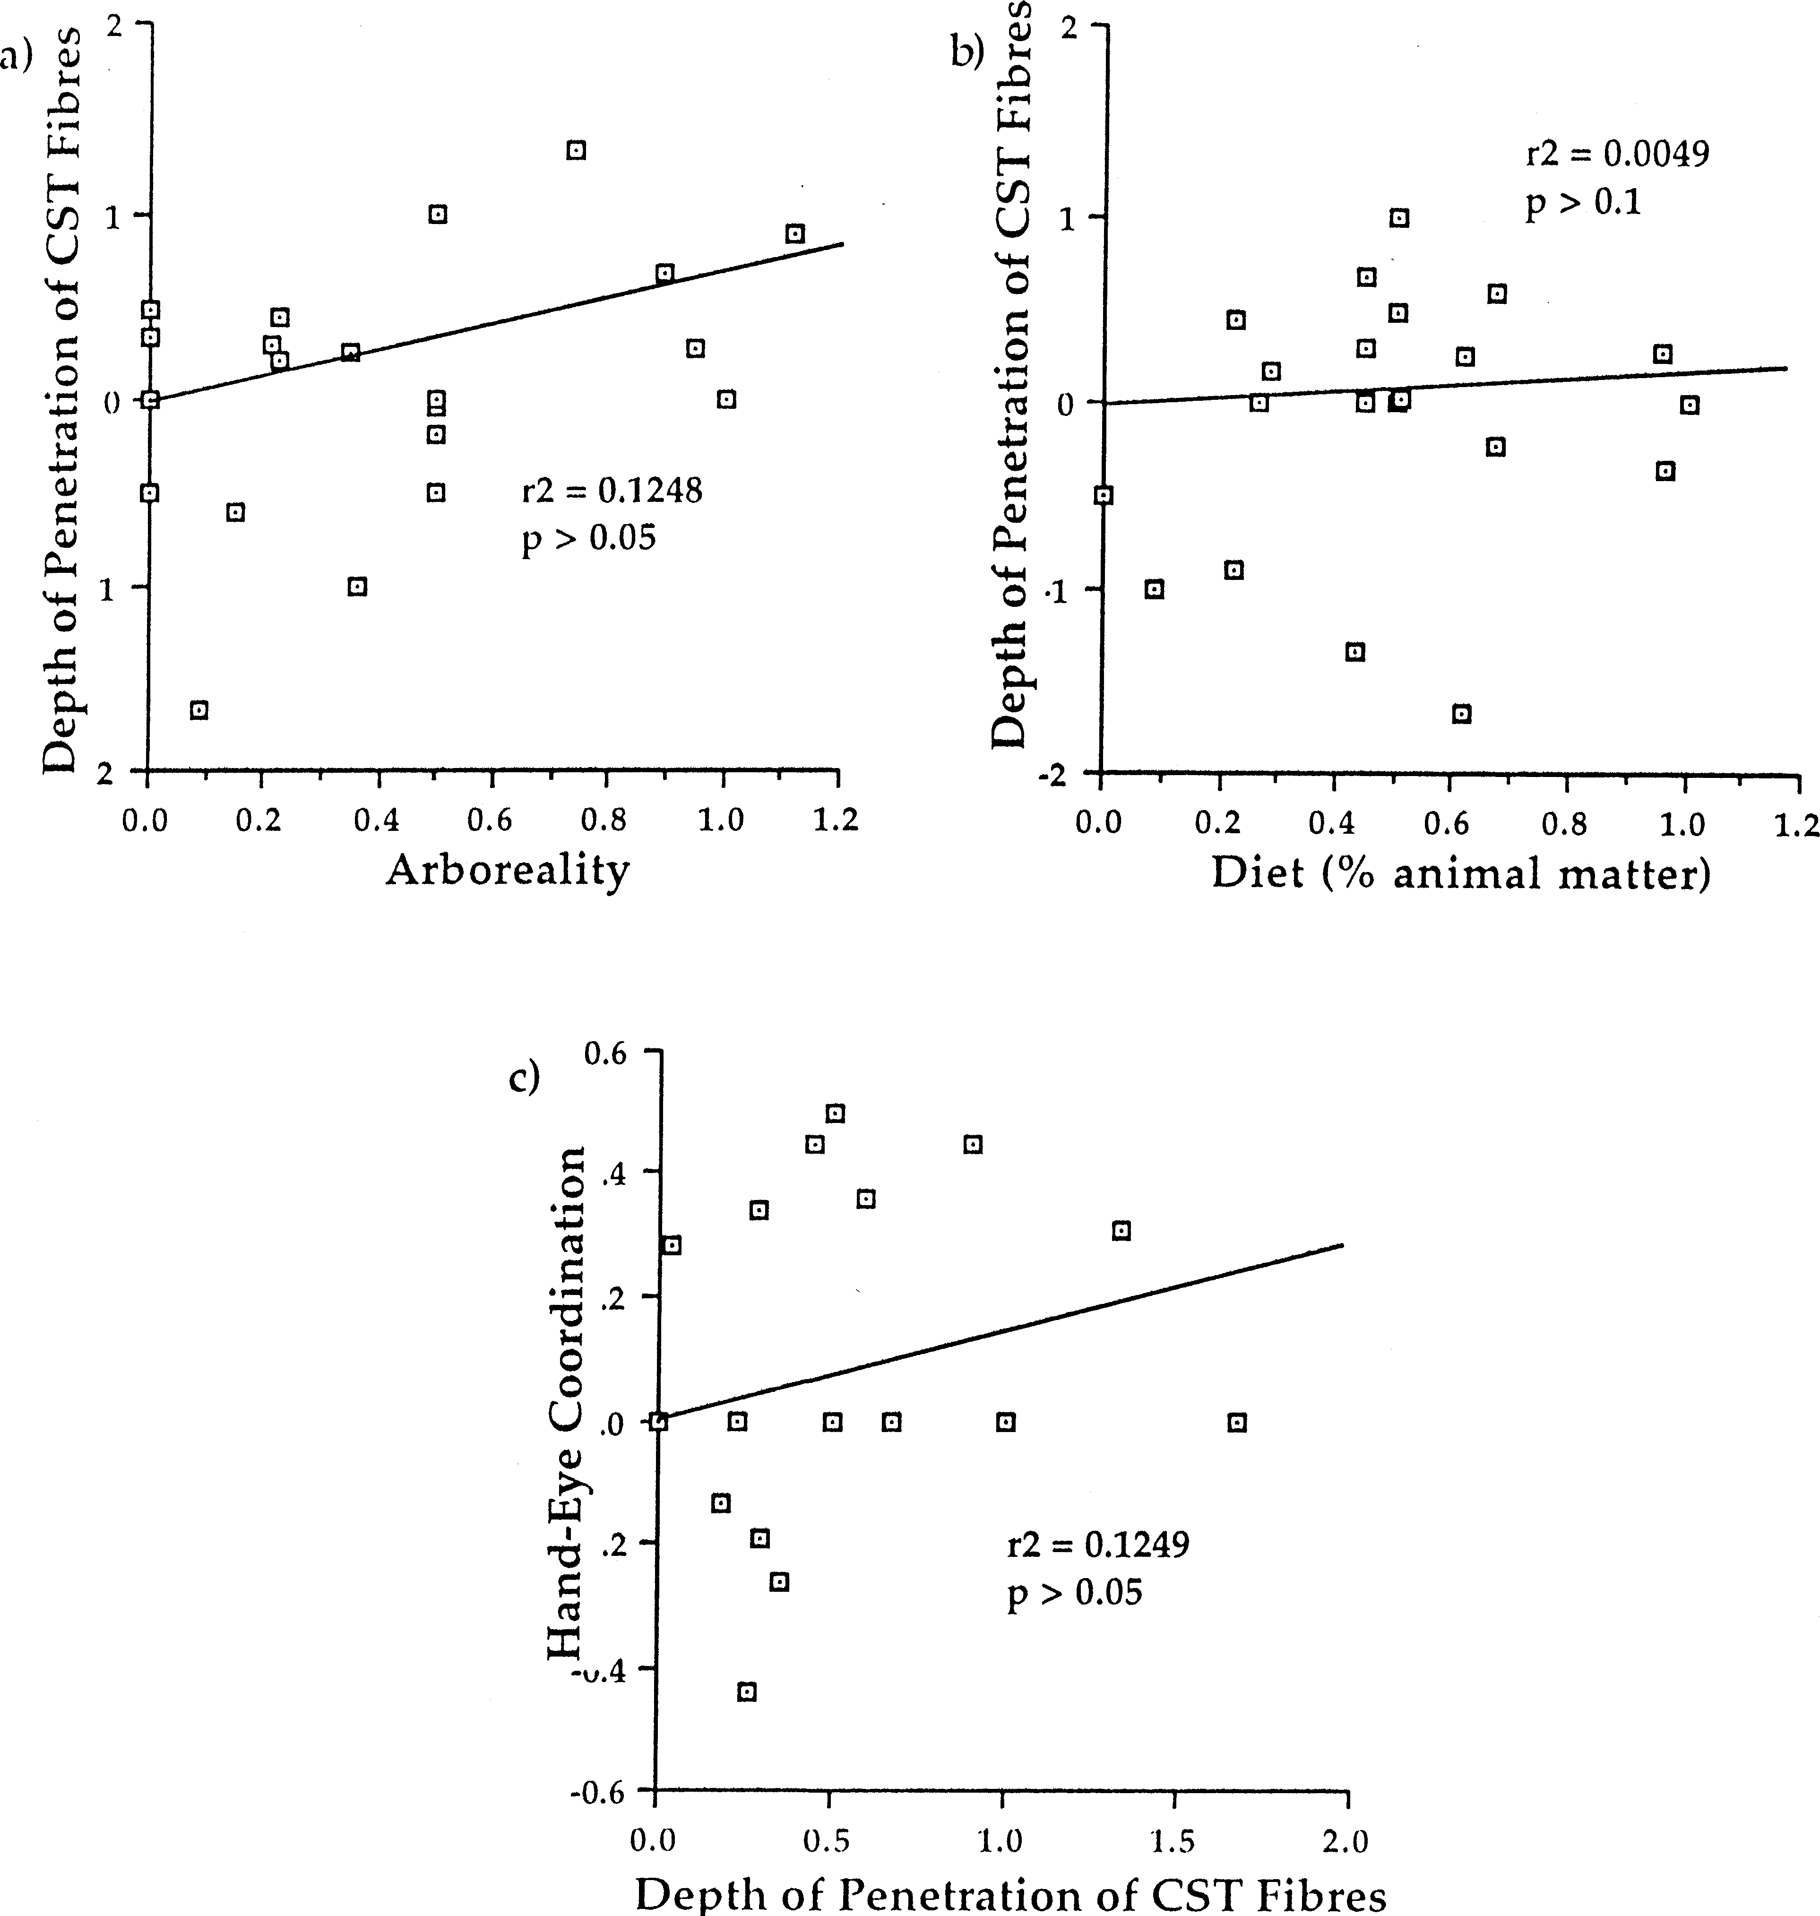
Fig. 7. These graphs represent the independent contrasts calculated for the depth of penetration of the corticospinal ﬁbres and the following behavioural variables: (a) arboreality, (b) diet and (c) hand– eye coordination. None of the relationships were signiﬁcant.

Table 3
Results from regression analysis of the square root of branch lengths and independent contrasts valuesª

Trait | F-value (d.f. °1, 23) | P-value
Depth Length  Digital Dexterity Aboreality  Diet  Hand–eye coordination | 0.162  1.584  3.378  0.391  0.095  5.932 | 0.6920  0.2227  0.0810  0.5389  0.7609  0.0294
ª A lack of a signiﬁcant relationship indicates that the calculated contrasts are properly standardised. Note that hand–eye coordination had a signiﬁcant correlation with branch lengths, indicating improper standardisation.

species sampled. Only ﬁve out of the 25 species exam- ined showed moderate to high amounts of animal matter in their diets (Table 1), the remaining 20 spe- cies either ate relatively small amounts of animal mat- ter or none whatsoever. Therefore, we may not have an accurate representation of the diversity of diet types present in extant mammals. We were, how- ever, limited in our selection of species to those for which accurate descriptions of the termination of the corticospinal tract were available. A more accu- rate depiction of mammals as a whole with substan- tially more predatory species may alleviate this potential source of error and yield a modiﬁed rela- tionship.

  - Hand – eye coordination

As with the measurement of dexterity, this measure has its ﬂaws and may not accurately represent the actual degree of hand– eye coordination exhibited by the species. This measurement, in particular, was not based upon any ‘real data’, rather it was an arbitrary score given to a set of various species by Nudo and Masterton [50] based upon whether the animals use vision to guide forelimb movements. Thus, any results based upon this index may be misconstrued by the subjectiveness of the original researchers.
Nevertheless, a signiﬁcant relationship was found between the length of the corticospinal tract and the hand– eye coordination index. This could suggest that the corticospinal tract is, in some way, involved in the coordination of forelimb movements and the guidance of the movements. Despite the problems as- sociated with this index, we feel that this is the most likely scenario: the development of the corticospinal tract is correlated with the degree of coordination re- quired to perform a task. This mode of evolution would account for the positive relationship between dexterity and hand– eye coordination and the length of the corticospinal tract as well as the lack of rela-
tionship between arboreality and the corticospinal tract.

Conclusions

Through the use of modern comparative techniques which take phylogenetic relationships into account, we have shown that previous comparative examina- tions of the corticospinal tract have been affected by a sampling bias in favour of primates. Despite this bias, once the effects of phylogeny have been re- moved, a signiﬁcant relationship remains between the length of the corticospinal tract and digital dexterity and hand– eye coordination. Thus, the corticospinal tract can be thought of as evolving diversity in the length of its ﬁbres as a means of increasing or de- creasing the amount of motor coordination required in the forelimbs, but not necessarily for creating spe- ciﬁc types of movement (e.g. independent digit move- ment). This hypothesis is supported by previous research into the function of the corticospinal tract as most, if not all, of the behavioural deﬁcits reported following corticospinal tract lesions or sectioning (for a review see Ref. [54]) can be explained just as parsi- moniously if they are considered to be a lack of coor- dination between limb segments, rather than a lack of motor ability [68]. Future research into this phe- nomenon should be directed towards assessing motor coordination and motor function during different be- havioural tasks and comparing it to corticospinal tract length.
The lack of relationship between the depth of pene- tration of the ﬁbres and any of the behavioural mea- sures examined remains puzzling. Why does such a diversity in the depth of penetration of the ﬁbres exist if there is no apparent connection between behaviour and depth? The best way to resolve the issue of the functionality of the corticospinal tract and how it re- lates to its anatomy is to broaden our knowledge of the diversity of the connections of the corticospinal tract by incorporating a more diverse array of spe- cies. Only at that point, can we begin to speculate on the evolution of the entire corticospinal tract within mammals as a whole.

Acknowledgements

Our thanks to Dr John L Gittleman for walking us through the use of modern comparative methods and to the two anonymous reviewers who greatly im- proved the quality of this paper. This paper was sup- ported by funding to IQW and a Post-Graduate Scholarship to ANI from the National Science and Engineering Research Council of Canada.

References

- Badyaev AV, Leaf ES. Habitat associations of song characteris- tics in Phylloscopus and Hippolais warblers. Auk 1997;114:40 – 6.
- Bautista NS, Matzke HA. A degeneration study of the course and extent of the pyramidal tract of the opossum. J Comp Neurol 1965;124:367 – 75.
- Bjorklund M. Are comparative methods always necessary? Oikos 1997;80:607 – 12.
- Bortoff GA, Strick PL. Corticospinal terminations in two New- World primates: further evidence that corticomotoneuronal con- nections provide part of the neural substrate for manual dexterity. J Neurosci 1993;13:5105 – 18.
- Broere G. Corticofugal ﬁbers in Chiroptera. Acta Morph Neerl- Scand 1966;6:324.
- Buxton DF, Goodman DC. Motor function and the corti- cospinal tract in the dog and raccoon. J Comp Neurol 1967;129:341 – 60.
- Campbell CBG. Pyramidal tracts in primate taxonomy. Diss Abstr 1967;27:2574.
- Campbell CBG, Yashon D, Jane JA. The origin, course, and termination of corticospinal ﬁbers in the slow loris Nycticebus coucang (Boddaert). J Comp Neurol 1966;127:101 – 12.
- Cartmill M. Climbing. In: Hildebrand M, Bramble DM, Liem KF, Wake DB, editors. Functional Vertebrate Morphology. Cambridge, MA: Harvard University Press, 1985:73 – 88.
- Cheverud JM, Dow MM, Leutenegger W. The quantitative assessment of phylogenetic constraints in comparative analyses: sexual dimorphism in body weight among primates. Evolution 1985;39:1335 – 51.
- Christel MI. Catarrhine primates grasping small objects: tech- niques and hand preferences. In: Anderson JR, Roeder JJ, Thierry B, Horenschmidt N Jr., editors. Current Primatology, Behavioural Neuroscience, Physiology and Reproduction, vol.
III. Strasbourg: Universite Louis Pasteur, 1994:37 – 50.
- Devoogd TJ, Krebs JR, Healy SD, Purvis A. Relations between song repertoire size and the volume of brain nuclei related to song: comparative analyses amongst oscine birds. Proc Roy Soc Lond Ser B 1993;254:75 – 82.
- Diaz-Uriarte R, Garland T Jr. Testing hypotheses of correlated evolution using phylogenetically independent contrasts: sensitiv- ity to deviations from Brownian motion. Syst Biol 1996;45:27 – 47.
- Eisenberg JF, Leyhausen P. The phylogenesis of predatory be- havior in mammals. Z Tierpsychol 1972;30:59 – 93.
- Fa JE, Purvis A. Body size, diet and population density in Afrotropical forest mammals: a comparison with neotropical species. J Anim Ecol 1997;66:98 – 112.
- Felsenstein J. Phylogenies and the comparative method. Am Nat 1985;125:1 – 15.
- Ferrer NG. Pyramidal system of greater galago. Anat Rec 1971;169:314.
- Fisher AM, Harting JK, Martin GF, Stuber MI. The origin, course and termination of corticospinal ﬁbers in the armadillo (Dasypus no6emcinctus mexicanus). J Neurol Sci 1969;8:347 – 61.
- Garland T Jr., Carter PA. Evolutionary physiology. Ann Rev Physiol 1994;56:579 – 621.
- Garland T Jr., Dickerman AW, Janis CM, Jones JA. Phyloge- netic analysis of covariance by computer simulation. Syst Biol 1993;42:265 – 92.
- Garland T Jr., Harvey PH, Ives AR. Procedures for the analysis of comparative data using phylogenetically independent con- trasts. Syst Biol 1992;41:18 – 32.
- Gittleman JL. Carnivore brain size, behavioral ecology, and phylogeny. J Mamm 1986;67:23 – 36.
- Gittleman JL, Luh H-K. On comparing comparative methods. Ann Rev Ecol Syst 1992;23:383 – 404.
- Goldby F. An experimental investigation of the motor cortex and pyramidal tract of Echidna aculeata. J Anat 1939;73:509 – 24.
- Goldby F, Kacker GN. A survey of the pyramidal system on the coypu rat, Myocastor coypus. J Anat 1963;97:517 – 31.
- Goodman DC, Jarrard LE, Nelson JF. Corticospinal pathways and their sites of termination in the albino rat. Anat Rec 1966;154:462.
- Grillner S. Neurobiology of vertebrate motor behavior— from ﬂexion reﬂexes and locomotion to manipulative movements. In: Edelman GM, Gall WE, Cowan WM, editors. Signal and Sense: Local and Global Order in Perceptual Maps. New York: Wiley, 1990:187 – 208.
- Haartsen AB, Verhaart WJC. Cortical projections to brainstem and spinal cord in the goat by way of the pyramidal tract and the bundle of Bagley. J Comp Neurol 1967;129:189 – 202.
- Harting JK, Noback CR. Corticospinal projections from the pre- and postcentral gyri in the squirrel monkey (Saimiri sciureus). Brain Res 1970;24:322 – 8.
- Harvey PH, Pagel MD. The Comparative Method in Evolution- ary Biology. Oxford: Oxford University Press, 1991.
- Heffner RS, Masterton RB. The role of the corticospinal tract in the evolution of human digital dexterity. Brain Behav Evol 1983;23:165 – 83.
- Heffner RS, Masterton RB. Variation in form of the corti- cospinal tract and its relationship to digital dexterity. Brain Behav Evol 1975;12:161 – 200.
- Ivanco TL, Pellis SM, Whishaw IQ. Skilled forelimb movements in prey catching and in reaching by rats (Rattus nor6egicus) and opossums (Monodelphis domestica): relations to anatomical dif- ferences in motor systems. Behav Brain Res 1996;79:163 – 81.
- Iwaniuk AN, Nelson, JE. Brain size and manual dexterity in marsupials (in preparation).
- Iwaniuk AN, Nelson JE, Pellis SM, Whishaw IQ. Reaching, grasping and manipulation of food objects by two tree kangaroo species, Dendrolagus lumholtzi and Dendrolagus matschiei. Austr J Zool 1998;46:235 – 48.
- Iwaniuk AN, Whishaw IQ How skilled are the skilled limb movements of the raccoon (Procyon lotor)? Behav Brain Res 1999; in press.
- Jane JA, Campbell CBG, Yashon D. The origin of the corti- cospinal tract of the tree shrew (Tupaia glis) with observations on its brainstem and spinal terminations. Brain Behav Evol 1969;2:160 – 82.
- Jeannerod M, Arbib MA, Rizzolatti G, Sakata H. Grasping objects: the cortical mechanisms of visuomotor transformation. Trends Neurosci 1995;18:314 – 20.
- Kuypers HGJM. Anatomy of the descending pathways. In: Brookhart JM, Mountcastle VB, Brooks VB, Geiger SR, editors. Handbook of Physiology, Section I.: The Nervous System. Mo- tor Control, Part I, vol. II. Baltimore, MA: Williams and Wilkins, 1981:597 – 666.
- Luh H-K, Gittleman JL, Kot M. Phylogenetic Autocorrelation (PA): A Manual. available from the authors at the Department of Zoology, University of Tennessee, 1995.
- Maier MA, Olivier E, Baker SN, Kirkwood PA, Morris T, Lemon RN. Direct and indirect corticospinal control of arm and hand motoneurones in the squirrel monkey (Saimiri sciureus). J Neurophysiol 1997;78:721 – 33.
- Martin GF, Fisher OM. A further examination of the origin, the course and the termination of the opossum corticospinal tract. J Neurol Sci 1968;7:177 – 87.
- Martin GF, Megirian D, Conner JB. The origin, course, and termination of the corticospinal tracts of the Tasmanian potoroo (Potorous apicalis). J Anat 1972;111:263 – 81.

- Martin GF, Megirian D, Roebuck A. The corticospinal tract of the marsupial phalanger (Trichosurus 6ulpecula). J Comp Neurol 1970;139:245 – 57.
- Martins EP, Garland T Jr. Phylogenetic analysis of the corre- lated evolution of continuos characters: a simulation study. Evolution 1991;45:534 – 57.
- Marzke MW, Wullstein KL. Chimpanzee and human grips: a new classiﬁcation with a focus on evolutionary morphology. Int J Primatol 1996;17:117 – 39.
- Napier JR. Prehensility and opposability in the hands of pri- mates. Symp Zool Soc Lond 1961;5:115 – 32.
- Novacek MJ. Reﬂections on higher mammal phylogenetics. J Mamm Evol 1993;1:3 – 30.
- Nudo RJ, Masterton RB. Descending pathways to the spinal cord, IV: some factors related to the amount of cortex devoted to the corticospinal tract. J Comp Neurol 1990;296:584 – 97.
- Nudo RJ, Masterton RB. Descending pathways to the spinal cord, II: quantitative study of the tectospinal tract in 23 mam- mals. J Comp Neurol 1989;286:96 – 119.
- Nyberg-Hansen R, Brodal A. Sites of termination of corti- cospinal ﬁbers in the cat. An experimental study with silver impregnation methods. J Comp Neurol 1963;120:369 – 92.
- Petras JM. Some efferent connections of the motor and so- matosensory cortex of simian primates and felid, canid, and procyonid carnivores. Ann New York Acad Sci 1969;167:469 – 505.
- Petras JM. Corticospinal ﬁbers in New World and Old World simians. Brain Res 1968;8:206 – 8.
- Petras JM, Lehman RAW. Corticospinal ﬁbers in the raccoon. Brain Res 1966;3:195 – 7.
- Porter R, Lemon R. Corticospinal Function and Voluntary Movement. Oxford: Clarendon Press, 1993.
- Purvis A. A comparative estimate of primate phylogeny. Phil Trans Roy Soc Lond Ser B (Biol Sci) 1995;348:405 – 21.
- Purvis A, Gittleman JL, Luh H-K. Truth or consequences: effects of phylogenetic accuracy on two comparative methods. J Theor Biol 1994;167:293 – 300.
- Purvis A, Rambaut A. Comparative analysis by independent contrasts (CAIC): an Apple Macintosh application for analysing comparative data. Comp Appl Biosci 1995;11:247 – 51.
- Ricklefs RE, Starck JM. Applications of phylogenetically inde- pendent contrasts: a mixed progress report. Oikos 1996;77:167 – 72.
- Shriver J, Matzke HA. Corticobulbar and corticospinal tracts in the marmoset monkey (Oedipomidas oedipus). Anat Rec 1965;151:416.
- Shriver J, Noback CR. Cortical projections to the lower brain stem and spinal cord in the tree shrew (Tupaia glis). J Comp Neurol 1967;130:25 – 54.
- Simpson S. The motor cortex and pyramidal tract in the raccoon (Procyon lotor, Linn). Proc Soc Exp Biol Med 1912;10:46 – 7.
- Springer MS, Kirsch JAW. DNA hybridization, the compression effect, and the radiation of diprotodont marsupials. Syst Zool 1991;40:131 – 51.
- Verhaart WJC. Comparative Anatomical Aspects of the Mam- malian Brain Stem and the Cord. Assen: Van Gorcum, 1970.
- Watson CRR. The corticospinal tract of the quokka wallaby. J Anat 1971;109:127 – 33.
- Whishaw IQ, Coles BLK. Varieties of paw and digit movement during spontaneous food handling in rats: posture, bimanual coordination, preferences, and the effect of forelimb cortex le- sions. Behav Brain Res 1996;77:135 – 48.
- Whishaw IQ, Gorny B. Arpeggio and fractionated digit move- ments used in prehension by rats. Behav Brain Res 1994;60:15 – 24.
- Whishaw IQ, Pellis SM, Gorny B, Kolb B, Tetzlaff W. Proximal and distal impairments in rat forelimb use in reaching follow unilateral pyramidal tract lesions. Behav Brain Res 1993;56:59 – 76.
- Whishaw IQ, Sarna JR, Pellis SM. Rodent-typical and species- speciﬁc limb use in eating: evidence for specialized paw use from a comparative analysis of ten species. Behav Brain Res 1998;96:79 – 91.

.

.

